Lab Status: Everything is working. The one area that I wanted to develop a little more is the error page for users not signed in when they access Team.

Three things I learned:

1. Re-Introduction to ASP.NET
2. The Identity System
3. Seeding
4. Authorization

Three Areas that I need to work on:

1. Layout of Visual Studio
2. The Identity System
3. Migration command line

Screenshots

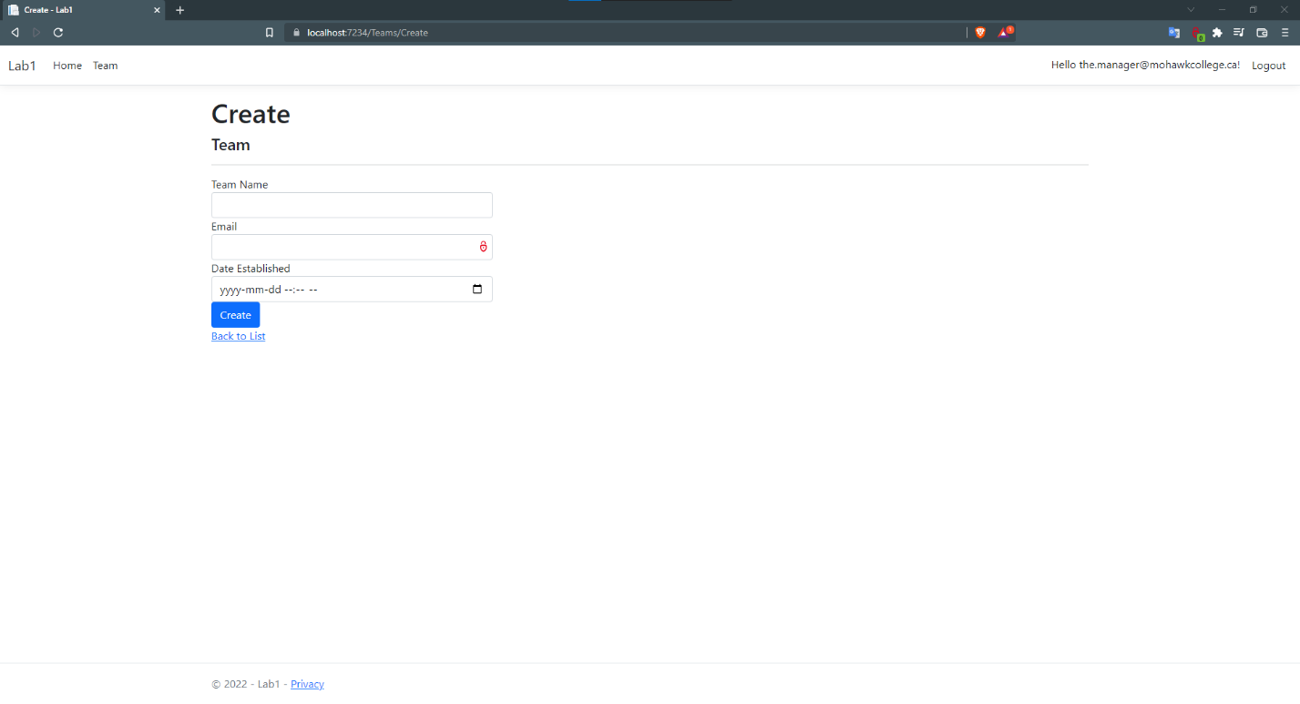

Figure : Create Screen as Logged in as a manager

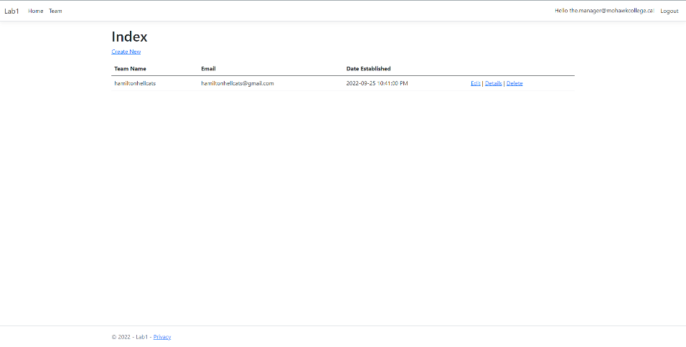

Figure : View Teams while logged in as manager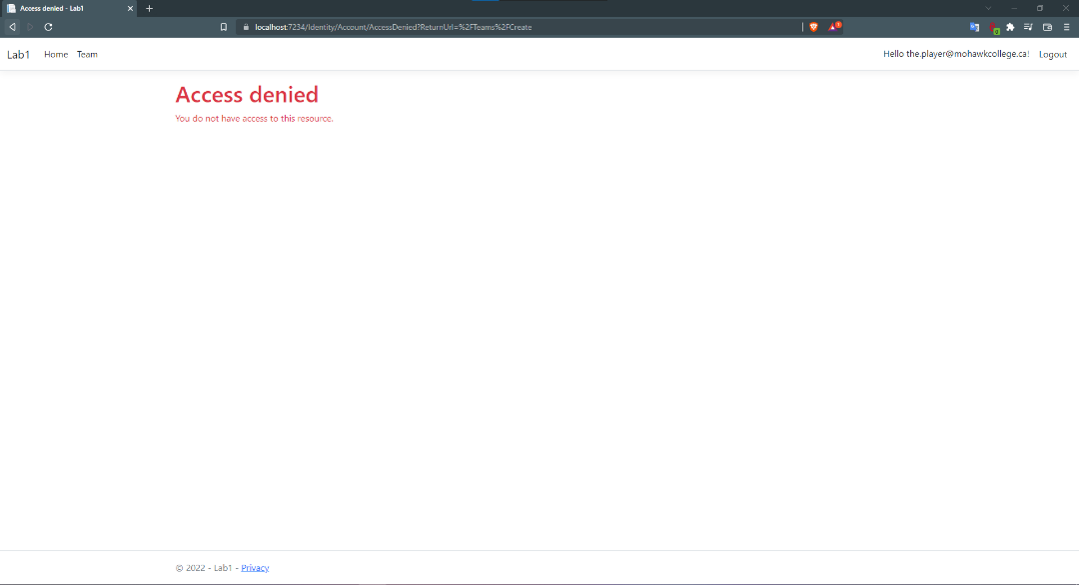

Figure :Create Team while logged in as Player

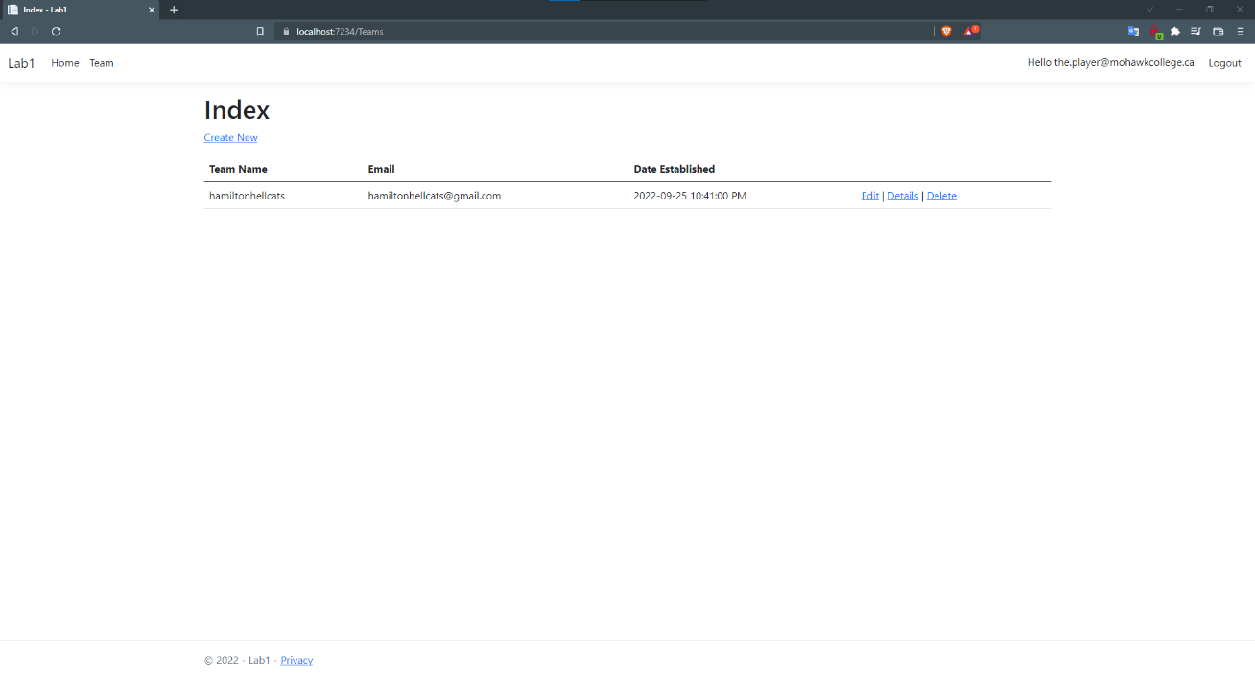

Figure : View Teams logged in as player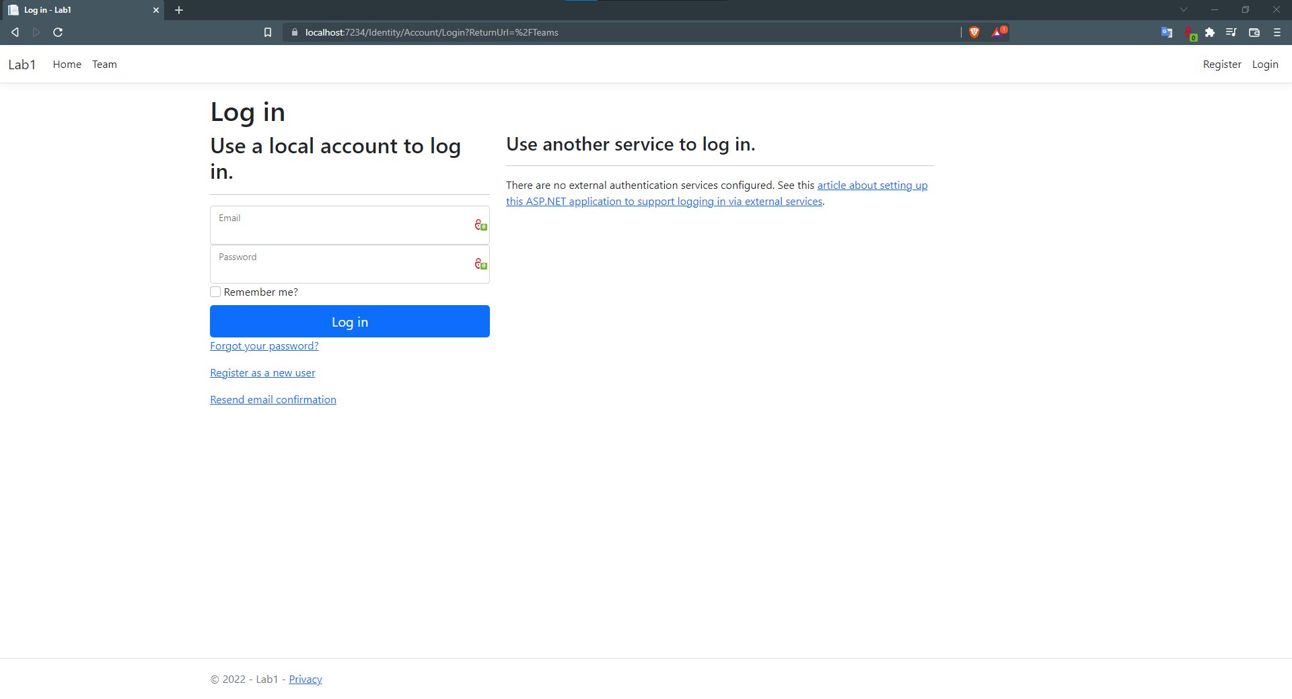

Figure : All unregistered users are redirected here